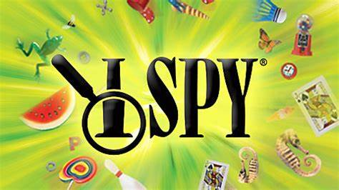

**Let’s play a game of I-SPY in the *Library’s Butterfly* *Garden.* (Located on the southwest side of the Library parking lot.) Be on the lookout for:**

 [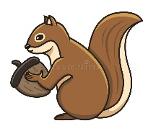](https://www.google.com/url?sa=i&url=https%3A%2F%2Fwww.dreamstime.com%2Fsquirrel-holding-acorn-vector-illustration-brown-white-background-outline-image-side-view-image155547062&psig=AOvVaw3OxcN0k-kWUR_MLr_lFY9P&ust=1592074467374000&source=images&cd=vfe&ved=0CAIQjRxqFwoTCPi85tr5_OkCFQAAAAAdAAAAABAI) [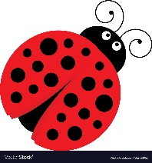](https://www.google.com/url?sa=i&url=https%3A%2F%2Fwww.vectorstock.com%2Froyalty-free-vector%2Fcute-cartoon-ladybug-vector-16236892&psig=AOvVaw16PcUEuIskZTQp58VciEw8&ust=1592417383338000&source=images&cd=vfe&ved=0CAIQjRxqFwoTCICizJb3huoCFQAAAAAdAAAAABAD)     

**(Objects may appear a bit differently)**

Check off the items as you find them. Take a picture of yourself in the butterfly garden and email it to [stephaniek@adamscountylibrary.info](mailto:stephaniek@adamscountylibrary.info).

*(You may just win a prize!!)*

Adams County Library

569 N. Cedar St.

Adams, WI 608-339-4250

***Submitted photos may be used on our Library website and Facebook page. Please let us know if you would prefer that we did* not.**